

FALCON’s Response to SAB Express RFQ
for the supply of SWEDI Sorter of Throughput 4000 PPH
May 15, 2023

Kind Attention –

Mr. Turab Rahaman

SAB Express

Offer Ref: F22-00317; Date 09.05.2023

Subject – Revised Proposal for the supply of SWEDI sorter of throughput 4000 PPH.

Dear Sir,

We are pleased to submit our Revised Offer for Supply of SWEDI Sorter
As you will note, we have studied your requirements in great depth and, along with the information collected during the workshops and calls with you, we have put together a detailed technical proposal.
In subsequent sections, we have highlighted the capabilities and experiences of Falcon Autotech as well as the capabilities of the proposed software.
To conclude, I would like to add my personal commitment, on behalf of Falcon Autotech. As we move through the RFP process, please do not hesitate to contact me and my team. We will be pleased to assist you for any further information or clarifications that you might have.
tails
Contact Person : Sanyog Singh
Title : Assistant sales manager
Mobile : +91-8750052591
Email : Sanyog.singh@falconautoonline.com

Company Details
Company Name : Falcon Autotech Pvt. Ltd.
Regd. Office : 57, Nimri Colony, Double Storey Flats, Delhi – 110052
Website : www.falconautotech.com
Linked ID : https://www.linkedin.com/company/falconautotech/mycompany/

Contents
1. Glossary 5
2. Company Profile 6
3. Falcon’s Experience and Achievements in Sortation Space Globally 14
4. Layout View 15
5. Handled Parcel Spectrum 16
a. Parcel size loadable on the sorter 16
b. Parcels to be loaded on Sorter shall have the following characteristics: 16
c. Parcel not loadable on the sorter 17
d. Pictures of Sortable Shipments 17
6. Key Modules 18
7. Key Component Makes 26
8. Proposed System Technical Details. 27
9. Price Schedule 28
10. Payment Terms. 28
11. Warranty Period 28
12. Delivery Schedule 28
13. Exclusions 29

Response Quotation for Swivel Wheel Diverts

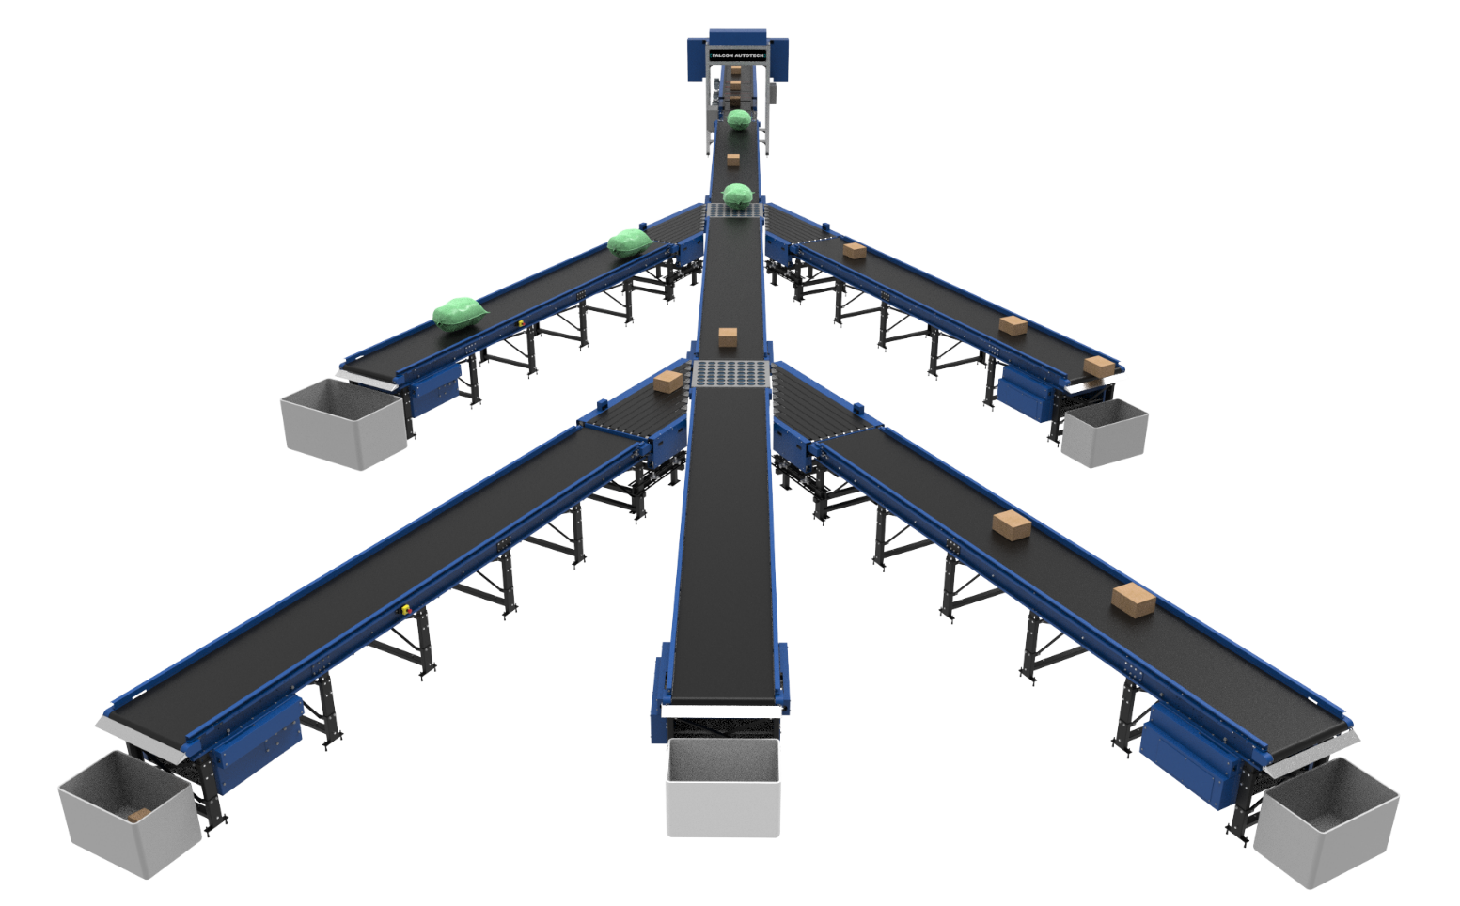

Proposal Reference - F22-00317.01

Falcon Autotech Private Limited
Plot No 308 & 309
Ecotech-1 Extension, Greater Noida
Uttar Pradesh- 201308
India.

Contact – Sanyog Singh
Assistant Manager
Mob - +91-8750052591
Sanyog.singh@falconautoonline.com

Glossary

S. No. | Term | Description
1 | RFQ | Request For Quote
2 | PPH | Parcels Per Hour
3 | ICR | Intelligent Character Recognition
4 | PLC | Programmable Logic Controller
5 | IT | Information Technology
6 | BOQ | Bill Of Quantity
7 | I/O | Input/ Output
8 | PC | Personal Computer
9 | UPS | Uninterrupted Power Supply

Company Profile


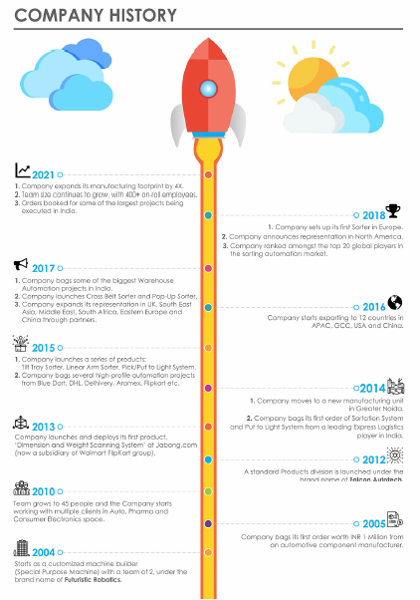

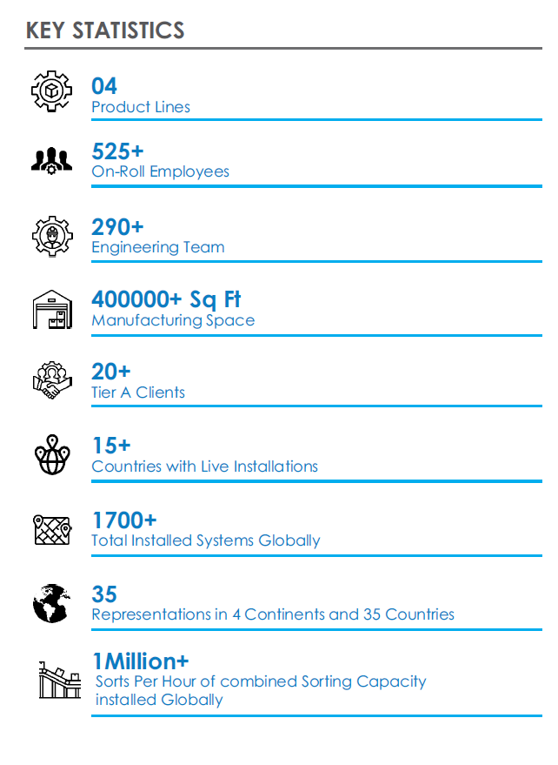

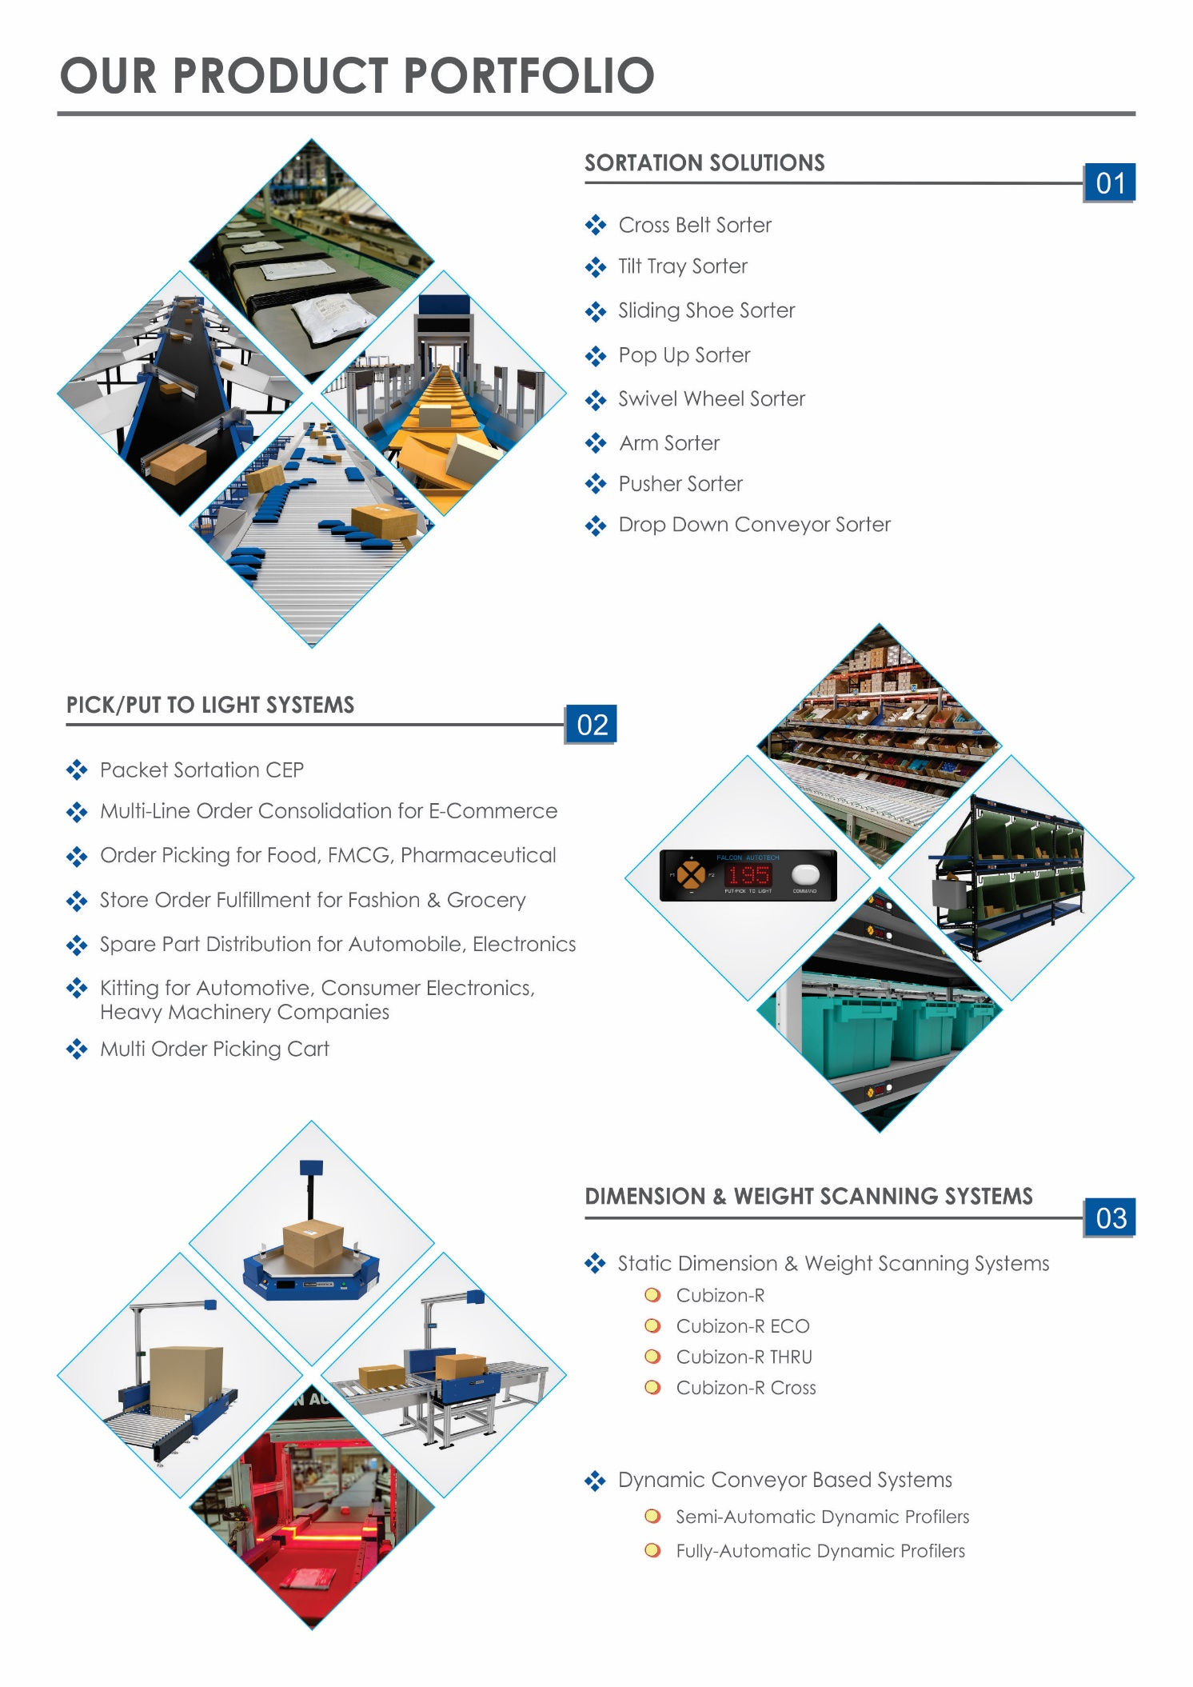

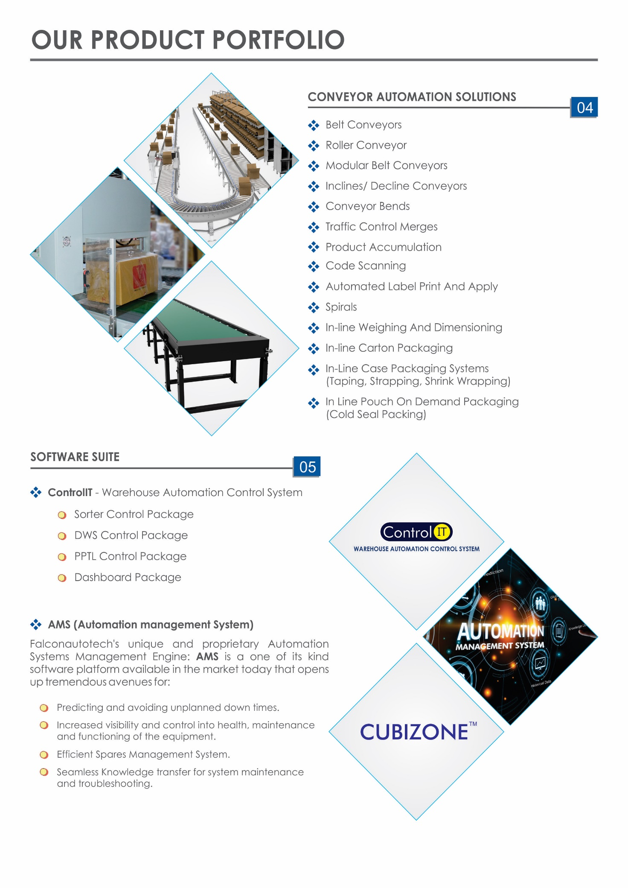



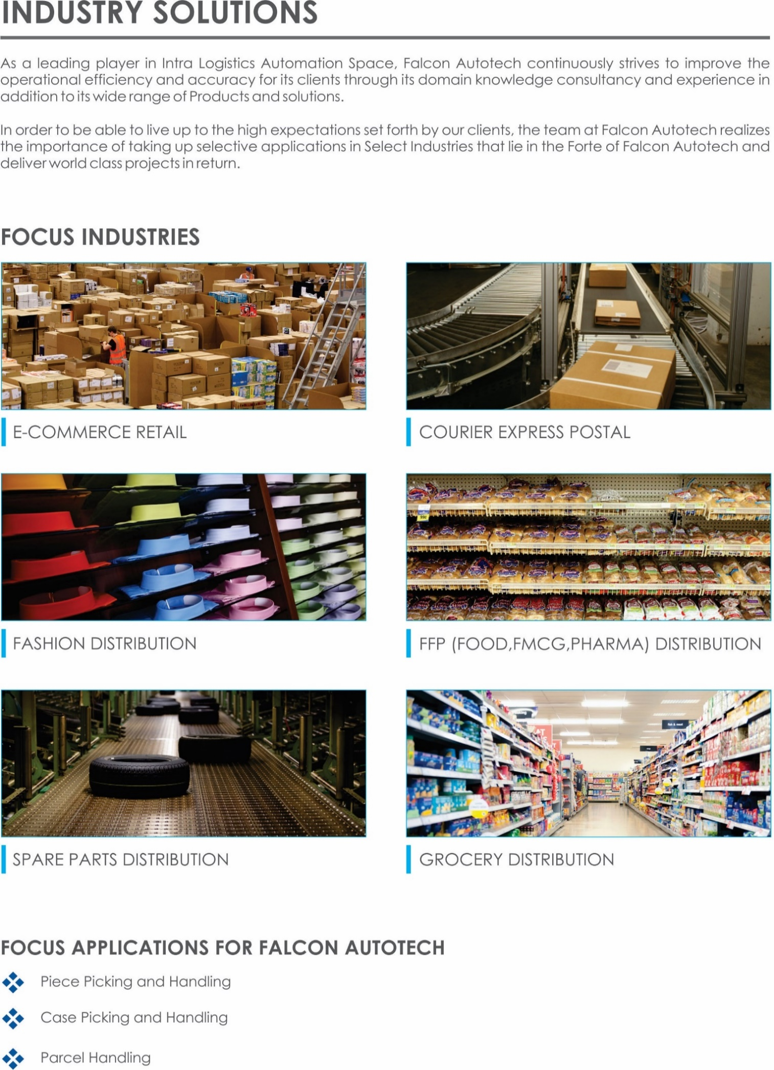



Falcon’s Experience and Achievements in Sortation Space Globally
- Ranked among Top 20 Sortation System Suppliers globally. Only company from APAC/EMEA Region.
- Currently possess one of the World’s largest portfolio in Sortation Technologies: 7 In-house technologies.
- Total installed capacity of 6 Million Parcels per day worldwide.
- Only company to be able to offer a Fully Integrated AMS.
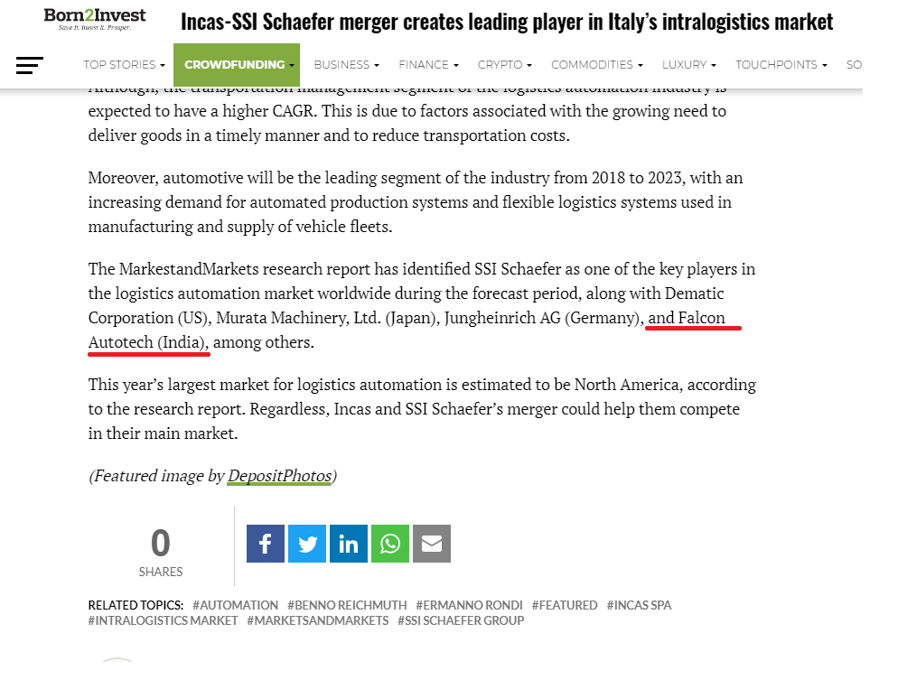

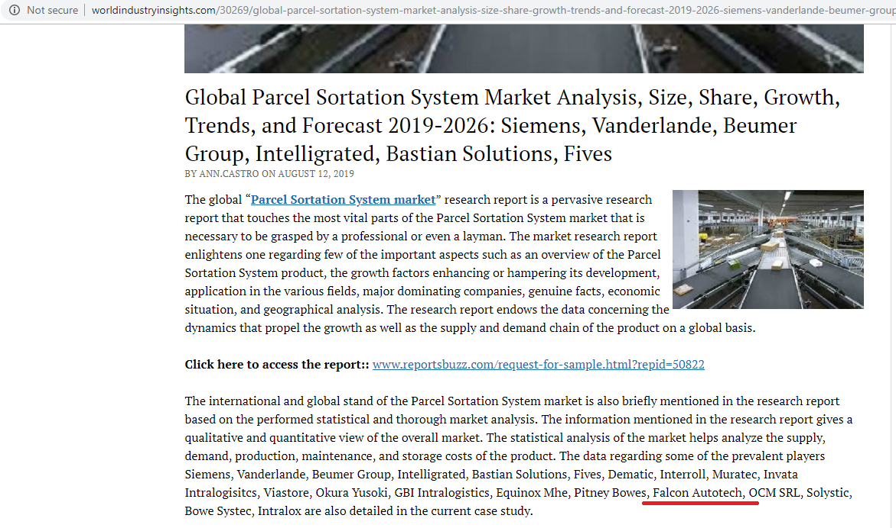

Kind Attention –

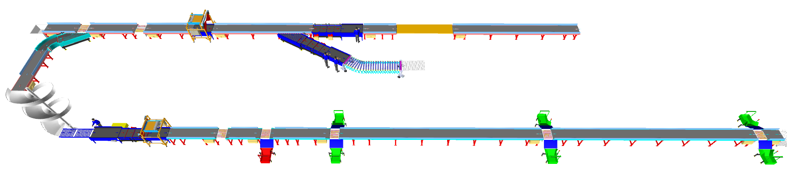
Layout View
Process notes

- Swivel wheel diverter is to be installed at ground floor and the basement.
- The system has 2 infeed points.
- At First Infeed Point:
- Shipments are loaded on to the infeed conveyor in a singulated manner.
- It will pass through the X-ray machine.
- The operator will check the shipments, reject the wrong ones, and orientate the rest in a manner that the bar code is on the top.
- At Second Infeed Point:
  - The pallets are fed into the system.
  - It will pass through the X-ray machine.
  - The operator will bring down the pallet from the conveyor, With the help of pallet handler. break it and fed it to the sorter in a singulater manner ensuring barcode facing top.
  - If the X-ray machine of first infeed will not work, then the shipments will also come from the second (pallet) x-ray machine. These shipments are being transferred from x-ray machine to the feedline through powered flexible roller conveyor.
  - Also, whenever the throughput number high pallet x- ray feedline used for shipment feeding.

- These shipments are then scanned by automatic scanner.
- The first sorting point is at ground floor. Rest of the shipments will be moved to the basement with the help of spiral chute.
- In the basement, there will be an operator who will orientate the shipment and ensure that the barcode is at the top.
- Then these shipments then further scanned by automatic barcode scanner.
- Based on 5 locations, the shipments will be sorted.
- There is rejection chute as well for rejected shipments.

Handled Parcel Spectrum
Dimensions Minimum Maximum

Parcel size loadable on the sorter

Product Range
Transported Items | Size | Length (mm) | Width (mm) | Height (mm) | Weight (Kg)
Carton boxes, Poly Bags | Maximum | 900 | 500 | 500 | 35
 | Minimum | 150 | 150 | 50 | 0.5

Parcels to be loaded on Sorter shall have the following characteristics:

- Centre of Gravity of item must not move during conveyance or sorting.
- Item must not have magnetic content, otherwise behavior of parcel cannot be guaranteed.
- Liquid or fragile material, to avoid breaking, spillage or leakage, such as wine bottles, metal cans of paint are designated as non- conveyable items.
- Parcels shall be perfectly and safely packaged: protrusion or open surfaces are not allowed.
- Plastic ropes shall be perfectly adherent to the surface of the package.
- Loose parts on loads and load carriers, such as adhesive tape, stickers, slips of paper, straps, wrap foil etc. are designated as non- conveyable items.
- All items with the risk of being damaged during the transport on an automatic sorting system or
damaging the sorting system. They must be robust enough to avoid disintegration of container material and loose of contents in the sorting process.
- Item packaging shall have enough grip to be handled on the belts during the acceleration and
referencing phases.
- Items shall not have slippery surfaces and must be able to withstand acceleration of the items on the belt during the start-stop phases (accelerations up to 0.5 g shall be assured without any sliding or tumbling of the items on the belt conveyor).
- The parcels must have at least one flat and regular surface providing enough stability during conveyance.
- Unstable items with a risk to roll or tumble on the sorting system, such as spherical or cylindrical items
- All shapes are permitted except spherical, cylindrical, or alike unstable items & shapes.
- All usual packaging materials are permitted (including paper, carton, plastics, plastic foil, rope, tape, textile, and wood)

Parcel not loadable on the sorter

All products that are not within the range as described here, are considered non- conveyable products, and must be taken out of the main sorter flow by the operators.

- Items that have a spherical or cylindrical shape.
- Items that are packed in material that can damage the conveyors or the sorter.
- Items that have sharp points (e.g. Nails) or sharp edges, that can damage the conveyors or the sorter.
- Fragile parcels with contents not sufficiently secured
- Items that have been classified as dangerous are designated.
- Wet items are designated.
- Items with anti-slip treatment.
- Items with protruding parts.
- Items with sharp edges.
- Inadequately packed items that could be damaged during automatic transportation.
- Electrostatically loaded items.

Pictures of Sortable Shipments

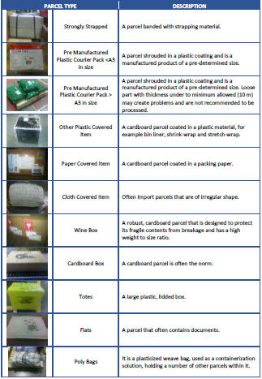

Key Modules

  - Automatic Feedlines
Fully automatic feedline is used in the system to induct parcels directly on to the sorter

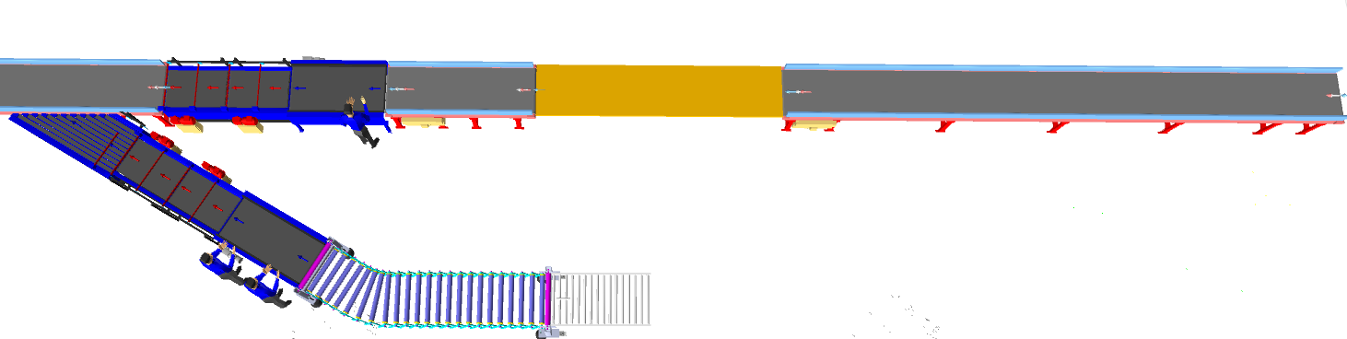

Feedlines consists of below components.

    - Infeed conveyors.
Shipments are loaded on this conveyor in a singulated manner after that it will pass through X- ray machine.
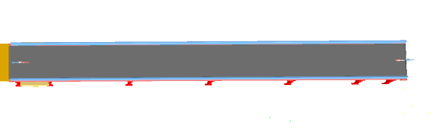

    - Plastic Modular Belt Conveyor
Falcon’s Belt Conveyors are modular & robust in design. MS profile is used to build conveyor frame.
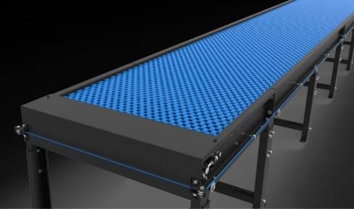
Some Salient Features of Falcon’s Modular Belt conveyor:
- Low Noise
- Maximum uptime.
- Minimal maintenance
- High safety standards.
- Fastest ROI.

Specification | UOM | Remark
Manufacturer Name | Name | Falcon Autotech
Plastic Modular Belt Material | Type | POM with PBT Pins, Pitch-25.4 mm, Pin Dia- 5mm
Plastic modular Belt Make/Model No. | Make | Movex/XP254 CR
Sprocket Size & No. of Sprockets on Drive End & Tail End | Type | 5/146.4 mm
Sprocket material | MOC | POM
Chassis | mm | MS, 3mm Thick, Powder Coated-75 Microns
Wear Strip Material | MOC | UHMW PE1000
Wear Strip Pitch | mm | 150 (Strip Width - 40mm)
Return Roller type | Type | DIA- 50 mm/20303
Return Roller Pitch | mm | 800
Driven Shaft | Type | MOC-EN9 Solid Shaft hardened to BHN 240, Size-60SQ MM, Zinc Plated -25 microns, Bearings-UCF-210D1
Duplex Sprocket | MOC | MS
Duplex Chain | MOC | MS
Drive Shaft | MOC | EN 24
Conveyor Under guarding | Type | GI SHEET (1MM THICK)
Type of Guides | Type | Steel guides at 50mm/400mm height basis the position of conveyor on both sides from Conveyor Belt Surface.

    - Shipment Loading Conveyor
It’s a approx. 2.5 m long. Powered Belt Conveyor for Shipment Loading. It is running at approx. 800 mm from ground Level.
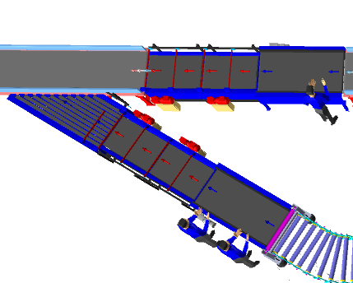
    - Detachable flexible conveyor.
Flexible conveyors are used to load and unload the shipments from truck. It let you change discharge points by rolling and curving conveyor sections to fit your needs. They're commonly used at shipping docks or the discharge end of a conveyor system to connect to truck trailers. A single conveyor can serve multiple dock doors.

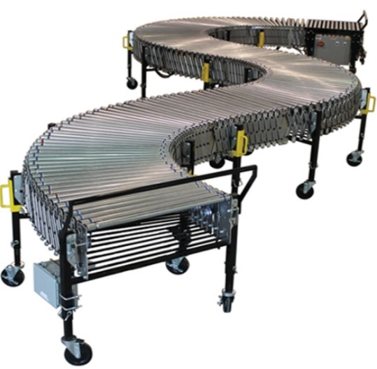

S. No | Description of Goods | Details
1 | Conveyor Width Between Frame | 800mm
2 | Conveyor Open Length | 10000mm
3 | Conveyor Closed Length | 5000mm
4 | Roller Close Pitch | 60mm
5 | Roller Open Pitch | 120mm
6 | Adjustable Height | 950 - 1200mm

    - Orientation Conveyor.

It’s a approx. 6 m long. Powered Belt Conveyor for Shipment Orientation running at approx. 800 mm from ground Level.

    - Spacing Conveyor
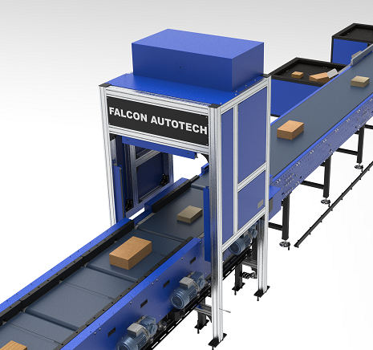
It’s a Special Conveyor, used to create space between parcels

    - Buffer conveyor
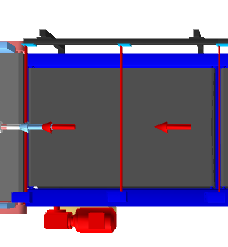
High-speed conveyor, used to create appropriate space between parcels/boxes and synchronize the infeed into the Sorter.

    - Intelligent merge / Angle merge.
This is 30° triangular Dual Belt high-speed conveyor used for inducting parcel/boxes directly on to the sorter. The Belts are Strip Belts for smooth parcel movement.

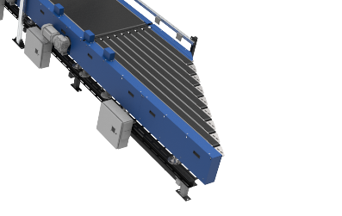
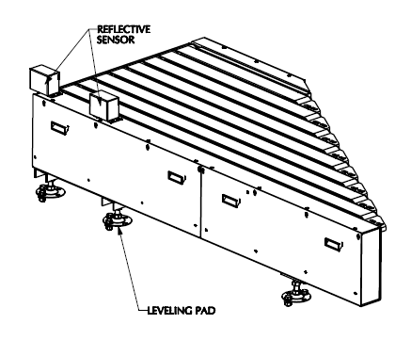

    - Spiral chute.
The Spiral chute is a compact and versatile elevating solution. It is specially designed chute which will take the shipments from G0 to Basement.

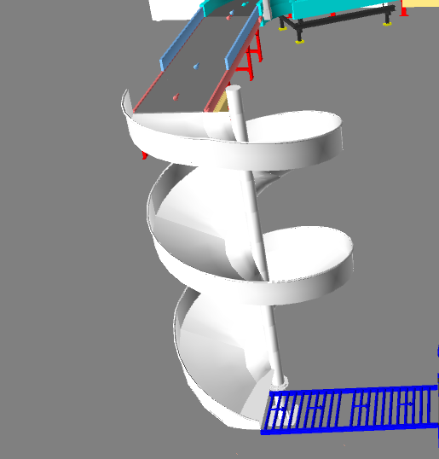

  - Barcode Scanning

    - Automatic Barcode Scanning
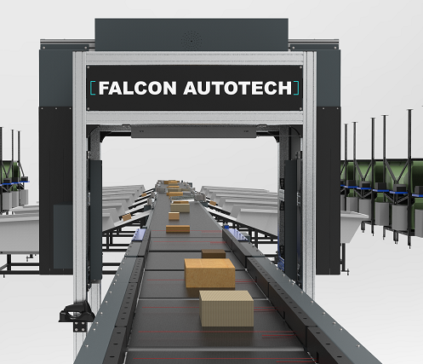
System is Integrated with Automated Line Scan Camera Technology (Sick ICR) for scanning 1D & 2D Barcodes.

Specification | UOM | Remark
Manufacturer Name | Name | SICK- ICR 890
Barcode Type | Type | 1D & 2D
Module Size | Mils | X or higher
Shipment Size | Mm | Min: 150 x 150 x 5  Max: 900 x500 x 500
Number of Codes | Nos | 1
Location | Side | Top
Orientation | Type | Top side
Color of bars | Color | Black
VMS | Nos | 1
Under Foil | yes/no | No

    - Handheld barcode Scanner
System is equipped with handheld barcode scanners capable for scanning 1D barcodes for Semi Auto mode.



  - Sorter: Swivel Wheel Divert
Swivel Wheel Diverter (SWEDI) is a non-impact sortation module for linear sortation lines, ideal for medium volume sort centres. SWEDI's modular design allows it to save space while also allowing for future expansion of sorting point
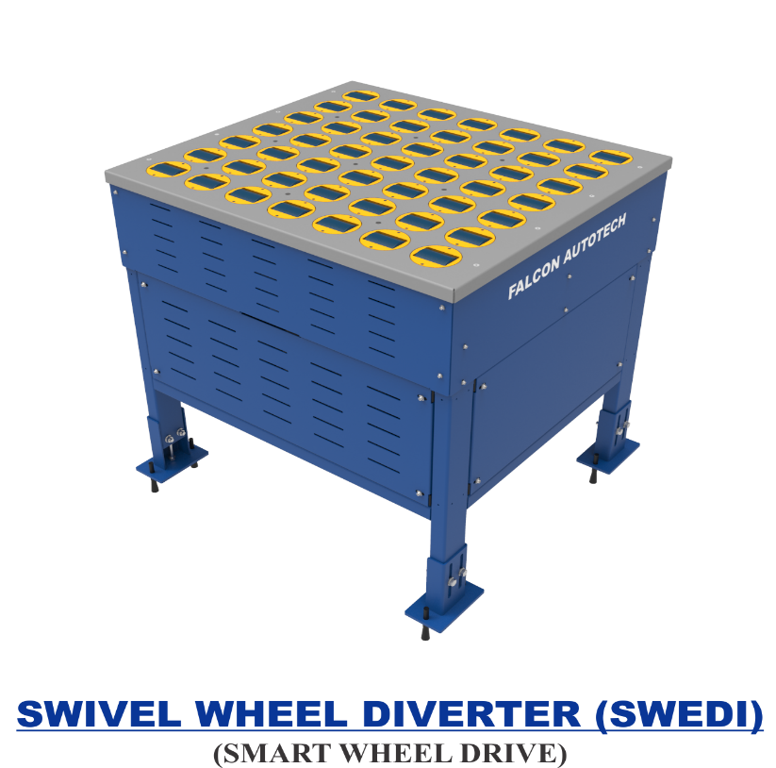

Technical specifications of SWEDI Unit
Items | Make
SWEDI Unit’s Dimensions | 815 mm (L) x 915 mm (W)
Load Capacity | 35 KG
Designed Throughput | 4000 PPH
Conveying Drive Unit | 48V, 50 Watt DC powered smart roller
Diverting Drive Unit | Servo Motor; 220V, 50HZ, 750W, Single Phase
Conveying Speed | Up to 120 m/min
Diverting Angle | 90 Degrees at double sides
Frame Material | MS Powder Coated Steel Frame
Stand Support | MS Powder Coated Steel Frame
PLC | Siemens
Servo Motor | Delta
Noise Level | <75 Db when measured from 1 m in a silent warehouse.

  - Sliding Chutes
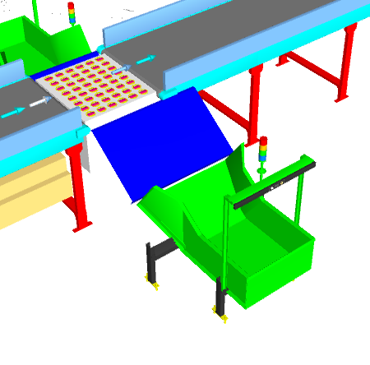
Parcels are collected in the in trolley with the help of sliding chute. The chutes are equipped with Chute full sensors and tower lamps.


  - Steel works.
Platform 3 SQM (Approximately).

Key Component Makes
S. No. | Description | Makes
1 | PLC | Siemen's
2 | HMI | Siemen's
3 | Control Cabinet & Accessories | BCH / Rittal
4 | Drives | Allen Bradely/ Lenze/ Siemen's
5 | Drive Motor and Gearbox | SEW/ Bonfigloili
6 | Sensors | Sick, P&F
7 | Bearings | SKF, NBC, NTN
8 | PVC Belt | Forbo, Derko,
9 | Rollers Make | Pulse/ Falcon
10 | Automatic Barcode Scanners | SICK/ Cognex
11 | Handheld Scanners | Motorola/ Honeywell

Proposed System Technical Details.
Mechanics
Pos. | Qty. | Description | Value
FM1 | 1 | Conveyor Automation
 |  | 02 x Angle merge.  13 x Powered Belt Conveyor; L-85 m  02 x Scanning Conveyor  03 x Spacing Conveyor  03 x Buffer Conveyor  03 x Receiving Conveyor  01 x 60-degree turn  01 x Detachable flexible conveyor L- 10m  01 x Modular Conveyor; L- 5.8 m; Width 1200 mm  02 x Gravity Roller Conveyor; L-4.8 m | Width-1000 mm
FM2 | 1 | Falcon Sorter-Swivel Wheel Diverter
 |  | System Width | 915 mm
 |  | System Length | 815 mm
 |  | 1 x Automatic Barcode Scanning System.
07 X Swivel Wheel Divert Units.
06 X Collection chute.
01 X Spiral chute
01 X Rejection
Controls
FC1 | 1 | Controls, IT and Wiring
 |  | Software Package
 |  | Control Panels
 |  | Sorter Control | Included
 |  | Electrical & Control Hardware
 |  | Switches
 |  | Drive panels
 |  | Operator Panels
 |  | Internal & Field Wiring

Price Schedule
Below chapter consists of Price of Falcon’s Mechanics and Controls.

S. No. | Description | Price (USD)
1 | Feedline and Sorter | $ 287,869
2 | Conveyors | $ 168,159
3 | Chutes | $ 5,901
4 | Falcon WCS and Integration | $ 8,684
5 | Tool Kit | $ 1,155
6 | Project Management and Engineering Charges | $ 12,385
7 | Packaging & forwarding | $ 23,178
8 | Operator Platform | $ 470
Grand Total (USD) Excluding Taxes. |  | $ 507,802

Note- Above price includes reversible feature in some conveyor modules; Details will be shared in DAP Stage. IT does not includes scanning the reversible direction.
Optional Price for Volume Measurement System is USD 26,600.00
Total Price is to be understood-
- Including Packing & Forwarding Charges
- Excluding Installation & Commissioning Charges
- Freight- Excluded
- Taxes Extra as applicable
- Unloading in Client’s Scope
- Laydown Area to be provided by SAB Express.

Payment Terms.
The Supplier Quotation is based on the following payment schedule:
Payment %age | Project Stage
50 % | Advance.
50 % | After inspection and clearance before dispatch.

Warranty Period
Falcons offered System comes with a standard warranty of 1 year and post completion of warranty, customer can opt for Extended warranty.

Delivery Schedule
22 to 24 weeks Ex-Works, Greater Noida from the date of PO, full payment, and DAP.

Exclusions
The scope of supply includes all parts which are defined in the Supplier’s quotation.
All other parts which are not defined in the Supplier’s quotation do not belong to the Supplier’s scope of supply and are excluded. The following parts are also excluded:

- Server PC & Server Rack
- Excluding installation and Commissioning
- Construction Power
- Steel Works- If not specified
- Collection Bin
- Building infrastructure; building structure, doors, fire exits, levelling devices, building extinguisher and fire alarm system, building heating and lighting system.
- Electrical power supply and wiring to the main control cabinets
- UPS for Controls and Drives
- Electrical Power for Installation
- Network Cabling up to the Main Server Rack
- Intermediate wiring to parts which are to be supplied by the Purchaser/others
- Emergency/Uninterruptable power supply
- Fire-alarm and fire protection devices
- Traffic and route markings
- Laydown Area
- Ram protection devices
- Cat walks, bridges, maintenance aisles and platforms
- Assembly tools like forklifts and hoisting machines
- All kind of network incl. Local Area Network (LAN/WLAN), exceeding the scope described in Scope of Supply
- Any Kind of Civil work
- Any adjustment of the Supplier’s scope of supply to local rules and regulations
- X-Ray machines
- Roller cages/ Pallets
- Simulation and 3D animation of the sorter system
- Interface with other equipment not specified in this offer.
- Provision of facilities for the control room (furniture, air conditioning, heating, etc.).
- The supply and installation of fencing around the different corridors.
- Any item specifically indicated as not forming part of the subject matter of the Seller's supply in the offer documentation.

